

SCHOOL UNIFORM POLICY
September 2026

It is the wish of the Governing Body that children should be dressed in school uniform and wear appropriate footwear. It is important to ensure all clothes are clearly marked with your child’s name.

It is important, and the expectation, that children are in the correct school uniform at all times

Our uniform expectation is now a PE style fleece style tracksuit, as noted below. This means there is only one uniform style for both daily wear and PE, reducing the need for two types of uniform, reducing cost, and has taken into consideration the sensory needs of a significant number of children within our school.
This uniform style was requested through the Pupil Parliament of the school and was agreed with them.

The school uniform expectations are:

- All black trainers only – no colours/ bright emblems/ coloured laces
- Navy tracksuit, fleece style (preferably school branded) – must be plain/ unbranded in design if you are not purchasing school branded items: see below
- Plain white polo T-shirt (branded or unbranded)
- For PE (can be worn under tracksuit): navy blue shorts or skorts (not beach wear)
- PE and swimming are important parts of the curriculum and children will need the correct items – these will be communicated with families before any swimming sessions, usually in Years 3, 4 & 5.
Please note:
- Leggings/ cycling shorts are not acceptable at any time.
- It is important that appropriate trainers, suitable for school, are worn. Do not send the children to school in fashion pumps or canvas shoes. Note that shoes with heels, open-toed footwear and Crocs are not allowed at any time, including non-uniform days.

During the academic year from September 2026, there is no requirement to change from the PE uniform from Bellfield Infant School/ Bellfield Junior School if the uniform still fits and is in good condition – change to the new school logo uniform when new uniform is required.

Items with the school logo can be purchased from -
* Kids Essentials, Bristol Road South, Northfield, Birmingham. B31 2NN
* Rubery Swap Shop: https://www.ruberyswopshop.co.uk/ (free uniform)

The school also has a uniform clothing bank and can support families if you need any help – just ask via in person, email or Class Dojo message.
Note: Although children must be in appropriate school colours as described, these do not need to be branded items – many supermarkets have good quality polo t-shirts, tracksuits and shorts in school colours. Iron-on school logo badges can be purchased from school.

Please note -
- For safety reasons, children should not be in school with any type of jewellery (watches (not smart-watches) are allowed). If ears are pierced, please ensure that only SMALL STUDS are worn. We assume you have given permission for children to wear stud earrings for PE and that you take responsibility unless you tell us otherwise – children will be asked to remove inappropriate earrings (such as dangling earrings) - these will be taped up. Due to the rules of Northfield Swimming Pool, no earrings are allowed when children are taken swimming by the school.
- Also, for safety reasons, hair longer than shoulder length should be tied up.
- We do not allow children to wear nail varnish, nail extensions, have coloured hair or inappropriate hair designs (patterned hair on boys is not allowed)– hair styles are expected to be sensible and modest. Please check with the school if you are unsure what would be acceptable.
- The wearing of headscarves for religious reasons is optional. They should be plain in colour (white or blue), should have no pins or fastenings and should have no words or other decoration.

It is important to ensure that you check the expectations of the school before buying uniform. If children are wearing incorrect uniform, the school will expect parents/ carers to return to school with the correct items for them to change into.
Please also note that it is not the responsibility of the school to find lost, unnamed clothing.
Acceptable examples:
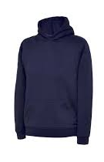
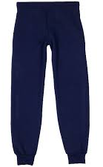
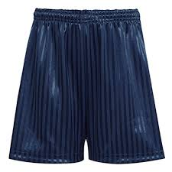
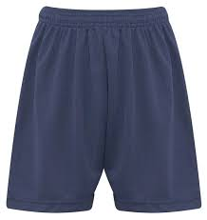
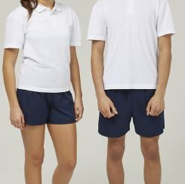

Only plain black trainers including for PE/ after-school sports clubs too. Trainers should have no colours (including laces), as examples shown below:
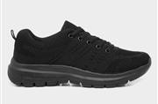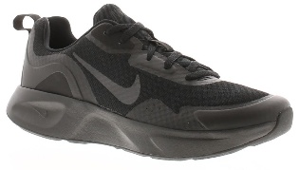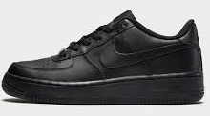
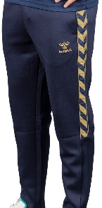
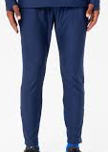
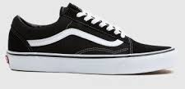
Anything else is not acceptable, such as:
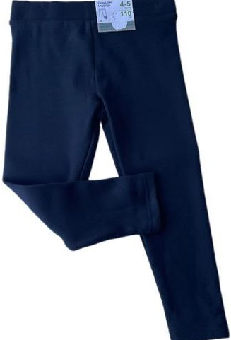
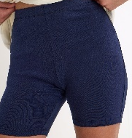
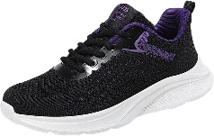
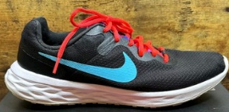


Agreed by Governing Body: ______________________________

Signed CoG: ___________________________ Date: _________

