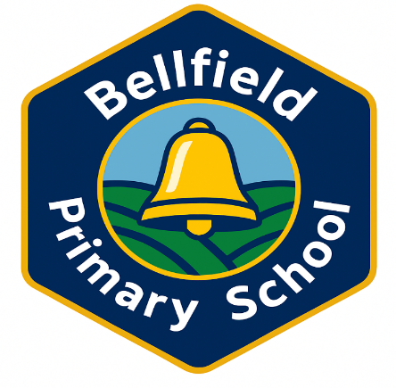
Packed Lunch Policy
Purpose of the policy
This policy aims to give clear guidance to Parents and Carers, pupils and staff on providing a healthy packed lunch. This has been agreed by Governors after research and guidance from different authorities.
We believe that a healthy packed lunch contributes to the health of children and young people and needs to be consistent with the nutritional standards provided by school meals. This policy applies to all packed lunches consumed within school, on school trips and school journeys taking place during the school day. It also applies to packed lunches provided by the school.
Foods to include
We ask that all packed lunches be based on the NHS’s food based standards for packed lunches (http:// https://www.nhs.uk/change4life/recipes/healthier-lunchboxes / ) and should include the following:
• Fruit and Vegetables: at least one portion of fruit and one portion of vegetables (seasonal if possible)
• Protein: meat, fish, egg or other source of non-dairy protein (e.g. lentils, kidney beans, chickpeas, hummus and dhal)
• Carbohydrate: starchy food such as bread, pasta, rice, couscous, noodles, potatoes, chapattis and roti.
• Dairy: food such as milk, cheese, yoghurt, fromage frais, or calcium fortified soya products, reduced fat versions of these should be used where possible
• Drinks: water, pure fruit juice (no added sugar), semi-skimmed or skimmed milk, reduced fat and sugar yoghurt or milk drinks and smoothies.
• Fruit based pudding such as fruit salad, tinned fruit with yoghurt or custard, fruity rice pudding, fruit smoothies, fruit based crumble Foods to avoid or limit
• A cake or a plain biscuit or a packet of crisps
• Meat products such as sausage rolls, individual pies, corned meat and sausages/chipolatas
Packed lunches should not include any of the following for any reason:
• Fizzy/sugary drinks in cartons, bottles or cans (including diet drinks and energy drinks which can contain high levels of caffeine and other additives which are not suitable for children)
• Confectionery such as chocolate bars, chocolate-coated biscuits and sweets.
• Chocolate spread or jam or nut/ peanut based products as a sandwich filling.

NOTE: NUTS OF ANY TYPE ARE NOT ALLOWED IN SCHOOL AT ANY TIME.

Special diets and allergies
We ask that Parents/Carers be aware of nut allergies. The school recognises that some pupils may require special diets that do not follow the national food standards exactly. In this case, parents and carers are asked to make sure that packed lunches are as healthy as possible and to discuss this with the school prior to sending in foods that do not meet this policy.
It is for these reasons pupils are also not permitted to swap food items.
Packed lunch containers
We ask that pupils and Parents/Carer :
• Provide a packed lunch container where food items can be stored securely and appropriately until the lunchtime period. Reusable plastic containers, rather than disposable plastic bags and bottles.
• Include an ice pack with packed lunches, particularly in the summer months, to reduce the risk of harmful bacteria growing if left in warm temperatures.
Facilities for packed lunches
We will:
• provide appropriate facilities to store packed lunches
• provide free, fresh drinking water
• provide appropriate dining room arrangements for all pupils, regardless of whether they have school lunches or packed lunches, and wherever possible, ensure that pupils with a packed lunch and pupils having school meals, are able to sit and eat together.
Monitoring to promote healthy eating
We will regularly monitor the content of packed lunches and involve pupils and staff.
School will confiscate food items from packed lunches that do not conform to the policy. If they are confiscated, the foods will be returned to the parent/ carer at the end of the day. If a child’s packed lunch is wholly inappropriate, they will need to be given an alternative if all of their food is confiscated.
The Packed Lunch Policy is inline with the DfE guidance to schools on allergy awareness and on portion sizes.
Working with parents and carers
We expect that all parents and carers will support this Packed Lunch Policy. We offer advice and guidance to parents/carers on packed lunches- please come in and see us.
References:
https://www.gov.uk/government/publications/school-food-standards-resources-for-schools/school-food-standards-practical-guide
https://www.schoolfoodmatters.org/sites/default/files/2023-03/Packed%20lunch%20guidance_0.pdf
https://www.gov.uk/government/publications/school-food-standards-resources-for-schools/allergy-guidance-for-schools
https://www.gov.uk/government/publications/school-food-standards-resources-for-schools/portion-sizes-and-food-groups
Policy Review
This policy will be reviewed as part of the schools agreed policy review process. In addition any major legislative or governmental changes regarding school food may lead to this policy being amended.
Date policy written: Sept 2026
Reviewed: Bi-annually

Signed: CoG: __________________ Date: ___________
Signed: HT __________________ Date: ____________

