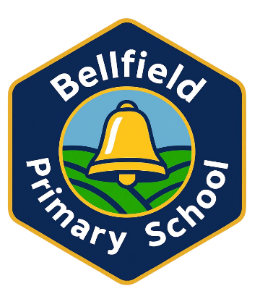

Bellfield Primary School

EYFS Policy

Date reviewed and updated: September 2026

School Vision
Bellfield Primary School is a welcoming and inclusive community where every child develops a lifelong love of learning within a culture of kindness. Children feel a strong sense of belonging, are treated with respect, and learn to believe in themselves and celebrate one another. Every child feels supported, inspired and motivated to reach their full potential.
Through high expectations and nurture, we develop their strengths and celebrate their achievements so they become confident, determined and curious individuals who are able to contribute positively to the world around them
School Values

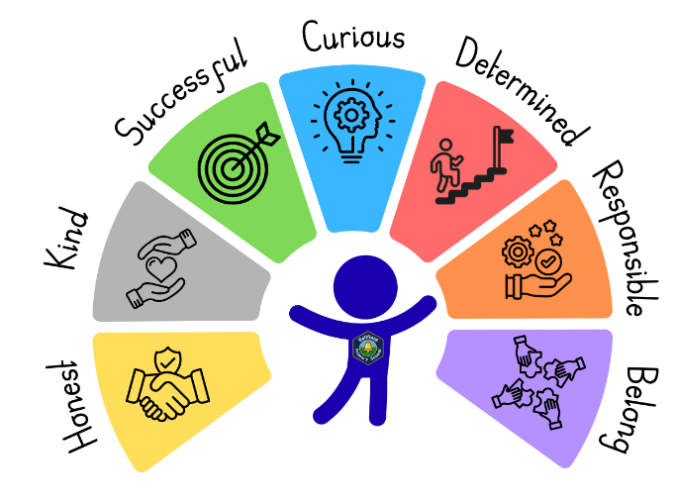

School Expectations
- Ready
- Respectful
- Safe

Our EYFS Vision
Our children will become curious learners, where we listen to the voice of the child. They will become independent and determined due to adults who interact, nurture and build relationships. We place the child at the heart of their own learning. We want children to be happy and engaged. Let us play.

EYFS Aims
At Bellfield Primary School we aim to have;
· Children who are happy, curious and engaged.
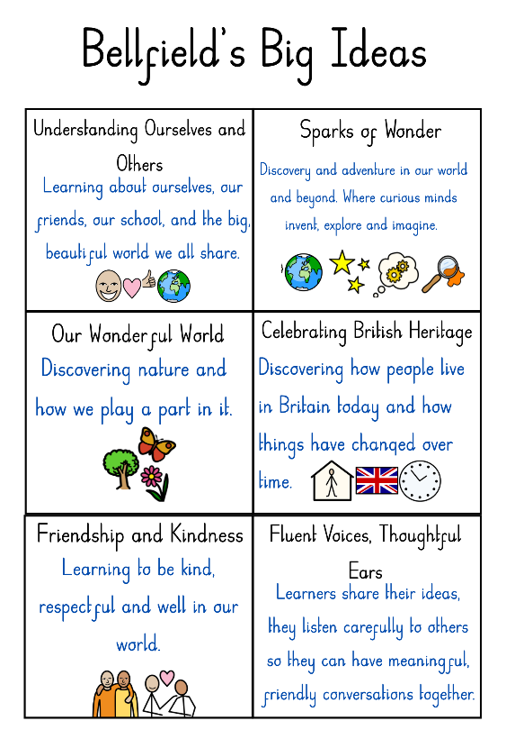
· Adults who; nurture, value, help them to build relationship, are partners in play.
· Parents who; work together, supportive, show mutual respect and for parents as partners in the child’s learning

EYFS Curriculum

The EYFS curriculum at Bellfield Primary School has been purposefully designed and tailored to meet the school's context and children's interests. The EYFS curriculum has been designed to meet the Bellfield Big Ideas - these drive our curriculum across the school and ensure it is broad, balanced and meets the needs of all our pupils. The EYFS curriculum in Nursery and Reception has been designed to be spiralling, carefully building upon pupil's prior knowledge and experiences. This makes them ready for the challenges that they may face. The curriculum has been designed with key vocabulary and knowledge in mind, as well as letting them develop the necessary skills required for KS1.

EYFS Statutory Guidance
At Bellfield Primary School, we follow the Early Years Foundation Stage (EYFS) statutory framework for group and school-based providers, effective from 1 September 2026. This statutory framework sets the standards that early years providers must meet for children’s learning, development, safeguarding and welfare.

The framework sets out the following requirements:
- Learning and Development
- Assessment Requirements
- Safeguarding and Welfare Requirements

Current EYFS statutory framework: https://www.gov.uk/government/publications/early-years-foundation-stage-framework--https://assets.publishing.service.gov.uk/media/6a5f8e4fb00f3323bf1a23a1/EYFS_group_and_school_based_from_September_2026.pdf

In our Early Years, we consider the EYFS guidance and the needs of pupils through:
- Building on what our children already know and can do; as we support children to work towards the early learning goals.
- Ensuring that all pupils succeed and that barriers to learning are removed.
- Supporting pupil’s learning that have a range of starting points, ensuring no child is left behind. Providing pupils with opportunities for learning that matches their needs providing opportunities for learning both indoors and outdoors.
- A rich and stimulating environment.
- Full working partnership with parents and carers to support the development of the child.
- Clear assessment arrangements for measuring progress.

In our EYFS we recognise that this is the most critical point of a child’s life. What a child learns in Nursery and Reception will impact on that child for the rest of their lives. It is vital that all pupils get the best start in life so that they are successful learners for the rest of the educational career and beyond.

The Early Years Foundation Stage is based on four overarching principles:
- A Unique Child
- Positive Relationships
- Enabling Environments
- Learning and Development

A Unique Child
At Bellfield Primary School, we recognise that every child is unique and has their own strengths and areas to develop. We recognise that children develop in their own individual ways and rates. We celebrate every child and their needs and encourage positive attitudes and dispositions to learning. We use praise and encouragement, celebration and rewards to motivate children to have a positive attitude.

We value the diversity of individuals within the school and believe that every child matters. All children at Bellfield, are treated fairly regardless of ethnicity, gender, religion or ability and we teach other children to do the same.

We give our children every opportunity to achieve their personal best and planning is adapted to meet the needs of all groups and abilities. We do this by taking account of our children’s range of life experiences, their needs and gaps they may have in their skills or knowledge.

In the EYFS we set realistic and challenging expectations keyed to the needs of our children, striving for high expectations of for all.

Positive Relationships
At Bellfield Primary School, having positive relationships is important to a child’s development. children learn to be strong, confident and independent from being in secure relationships. We aim to develop caring, respectful, professional relationships with all children and families. We do this by;

- Parents/ Carers as partners in their child’s learning and involving parents throughout their child’s journey.
- Talk to parents/ carers through parents’ evenings, stay and plays, informal meetings about phonics or other areas of the curriculum. Class Dojo and meetings.
- Arranging home visits where needed before pupils start school.
- A home school agreement between school and parents.
- Sharing the child’s learning journal with parents/ carers using Tapestry.
- Offering a range of activities, throughout the year, to encourage specific collaboration between child, school and parents
- Having an open-door policy where parents can arrange to speak to the class teacher or senior leaders about any concerns they have.

Children thrive from a base of loving and secure relationships. In Nursery, all children are allocated a key person who helps those children in the group feel safe and cared for. The key person responds sensitively to children’s feelings and behaviours. Meeting emotional needs by giving reassurance, such as when they are new to a setting or class, and supporting the child’s well-being. The key person will also support the child in their learning by keeping records of observations and development, sharing them with the Nursery team. They will also lead small group work activity and develop a group of children’s learning further. The class teacher has the overall responsibility of the class but works closely with your child’s key worker to plan ways forward and next steps.

Enabling Environments
At Bellfield, we embrace the theory “the environment acts as a third teacher”, research informed by the Reggio Emilia approach. Physical spaces hold the potential to influence what and how children learn. An enabling environment will; support children’s attitudes to learning, develops communication and language, encourages positive relationships, sustains a child’s thinking and curiosity.

Children access continuous provision both indoor and outdoors and are allowed to explore in different areas throughout the day. Areas are planned to facilitate children’s learning based on their needs, curriculum themes and provoke children’s curiosity and wonder.

Learning and Development
We use Development Matters and Birth to Five, as non-statutory curriculum guidance, to support our professional knowledge of how children develop and learn. It informs curriculum planning and professional judgement but is not used as a checklist or statutory assessment framework.

https://assets.publishing.service.gov.uk/media/64e6002a20ae890014f26cbc/DfE_Development_Matters_Report_Sep2023.pdf

https://birthto5matters.org.uk/wp-content/uploads/2026/08/Bto5M-PT-LINKS-Aug-Portrait-Landscape.pdf

The EYFS statutory framework sets out seven areas of learning and development, comprising three prime areas and four specific areas.

Children receive a balance of adult led and child-initiated activities in order for most children to reach their Early Learning Goals at the end of Reception.

The Three Prime Areas
- Personal, Social and Emotional Development
- Communication and Language
- Physical Development

Specific Areas
- Literacy
- Mathematics
- Understanding the World
- Expressive Arts and Design

Ongoing assessment is an integral part of learning and development. Practitioners use their day-to-day interactions, observations and professional knowledge of each child to understand progress, identify needs and shape teaching. Assessment should be proportionate and should not require excessive evidence collection. Where a child’s progress gives cause for concern, staff will discuss this with parents/carers and agree appropriate support.

Reception pupils also participate in a daily phonics session, following the ‘Read, Write Inc.’ program and in line with school policy and daily writing through Drawing Club. Nursery have daily listening and attention sessions, that develop the necessary skills to begin to learn phonics in the summer term.

Curriculum Organisation and Sequencing
Our EYFS curriculum is organised through half-termly themes. These themes provide meaningful contexts through which the seven areas of learning are taught, while ensuring that the intended knowledge, vocabulary, skills and experiences are deliberately planned and sequenced.
The curriculum is progressive and spiralling from Nursery into Reception. Important concepts, knowledge and vocabulary are revisited in increasingly demanding contexts so that children can remember more, make connections and build securely on prior learning. Planning identifies what children need to know and experience at each stage, while continuous provision and responsive adult interaction provide opportunities to practise, apply and deepen learning.
By the end of Reception, our curriculum is designed to give children the foundational knowledge, language, behaviours and learning dispositions they need to access the Key Stage 1 curriculum successfully, while remaining firmly rooted in the play, exploration and effective teaching approaches required in the EYFS.

Characteristics of Effective Learning
We ensure that our environment and delivery of the curriculum incorporates the three characteristics of effective teaching and learning:

Playing and Exploring - children will have opportunities to investigate and experience things, and ‘have a go’.
‘Children’s play reflects their wide ranging and varied interests and preoccupations. In their play children learn at their highest level. Play with peers is important for children’s development.’
Through play, our children explore and develop learning experiences, which help them make sense of the world. They practise and build up ideas, learn how to control themselves and understand the need for rules. They have the opportunity to think creatively alongside other children as well as on their own. They communicate with others as they investigate and solve problems.
Active learning - children will have time and space to concentrate and keep on trying if they encounter difficulties, and enjoy their achievements.
‘Children learn best through physical and mental challenges. Active learning involves other people, objects, ideas and events that engage and involve children for sustained periods.’
Active learning occurs when children are motivated and interested. We provide our children independence and control over their learning. Our children develop their confidence and learn to make decisions. Children gain a sense of satisfaction as they take ownership of their learning.
Sustain Thinking and Thinking Critically - We encourage and support children to have and develop their own ideas, make links between ideas, and develop strategies for doing things.
“When children have opportunities to play with ideas in different situations and with a variety of resources, they discover connections and come to new and better understandings and ways of doing things. Adult support in this process enhances their ability to think critically and ask questions.”

Children are given the opportunity to be creative through all areas of learning. Adults can support children’s thinking and help them make connections by showing interest, offering encouragement, clarifying ideas and asking open ended questions. Children can access resources and move around the classroom freely and purposefully to extend their learning.

Learning Journals and Observations
In EYFS, staff are skilled at observing children to identify their achievements, interests and next steps for learning. These observations then lead the direction of the planning. Relevant and significant observations are recorded in the children’s Learning Journals. Observations are required to be purposeful when recorded.

Assessment Requirements
In accordance with the EYFS statutory framework, children in Reception complete the statutory Reception Baseline Assessment (RBA) within the first six weeks in which they start Reception. Requirements also apply to children who enter Reception later in the academic year, in accordance with the current RBA administration guidance.

https://www.gov.uk/government/publications/reception-baseline-assessment-information-for-parents

https://www.gov.uk/government/publications/early-years-foundation-stage-framework--2

We assess pupils formally three times each academic year, in October, February and June. These assessment points complement ongoing formative assessment and allow practitioners and leaders to review children’s progress, identify pupils who may need additional support and evaluate the impact of teaching and curriculum provision using the Early Excellence Reception Assessment tool.

Assessment in the Foundation Stage takes the form of both formal and informal observations and through planned activities. Assessment is completed regularly and involves both the teacher and other adults, as appropriate.

The teacher keeps records, learning journals and records examples of each child’s work. These progress books contain a wide range of evidence that we share with parents at each parental consultation meeting.

The school uses an online tracking system to record the three assessment points. In Nursery, judgements draw on practitioners’ knowledge of the child and the curriculum, informed by Development Matters. In Reception, assessment is made in relation to the Early Learning Goals (ELGs). At the end of the EYFS, each child is assessed against all 17 ELGs as either meeting the expected level of development or as emerging, in accordance with the statutory EYFS Profile requirements.

Good Level of Development (GLD)
At the end of Reception, a child is considered to have achieved a Good Level of Development (GLD) when they meet the expected level in the Early Learning Goals within all three prime areas of learning, together with the Early Learning Goals for Literacy and Mathematics. GLD is therefore a summary measure drawn from the statutory EYFS Profile. It indicates that a child has reached the expected level across these key aspects of learning at the end of the EYFS; it does not mean that a child has completed learning in these areas, and individual strengths and needs continue to inform transition into Year 1.

Parents/ Carers receive an annual written report that offers brief comments on each child’s progress in each area of learning. It highlights the child’s strengths and development needs, and gives details of the child’s general progress. These are sent to parents in July.

Safeguarding & Welfare

The EYFS Framework explains to school the legal requirements around safeguarding pupils within Reception and Nursery. Our school has a safeguarding and child protection policy that is compliant with EYFS Framework. As well as this, Deputy Headteacher and EYFS lead is Deputy Designated Safeguarding Lead.

At Bellfield Primary School, we provide a setting that is welcoming, safe and stimulating where children can grow in confidence and be nurtured.

It is important to us that all children in the school are ‘safe’. We aim to educate children on boundaries, rules and limits and to help them understand why they exist, through the EYFS curriculum we provide. We develop pupil’s life skills e.g. making choices, sharing or resolving difficulties with others. We encourage children to take risks and highlight the importance of keeping themselves safe by teaching them how to recognise and avoid hazards. We aim to protect the physical and psychological well-being of all children.

All children are provided with a healthy snack each day as well as being given the choice of milk. They always have access to water. The children are taught about healthy foods and choices in a variety of ways through the curriculum.

We fully support our children’s mental health and well-being by teaching a range of activities to promote healthy bodies and minds. The school has a pastoral lead (Beccy Brittle) who takes a proactive approach in supporting pupil’s wellbeing across the school.

We recognise the children bring different home life experiences and staff are fully committed to supporting their well-being and providing support for parents when needed. Staff will guide parents to seek additional help and will inform SENCO or Head teacher for support.

Safeguarding updates from September 2026
In line with the EYFS framework effective from 1 September 2026, the school has regard to the statutory requirements and associated guidance relating to children’s screen use. Digital technology is used purposefully and appropriately, with staff considering children’s age, development, safety, wellbeing and the value that screen use adds to learning.
The school follows the strengthened suitability requirements for people working or volunteering with children, including the relevant enhanced criminal records and barred-list checking requirements before individuals begin working or volunteering in the setting. Safeguarding procedures also reflect the current framework requirements concerning allegations of harm and staff suitability disclosures.
Where sleeping arrangements are relevant to the provision, the school follows the safer-sleep requirements within the current EYFS statutory framework.

Intimate Care
We recognise that not every child maybe confident at intimate care. Depending on a child’s age and stage of development, they may need some support, for example dressing, wiping their bottom after using the toilet and changing underwear following an accident. In most cases, intimate care in Reception is about personal hygiene

Every child has the right to privacy, dignity and a professional approach from all staff when meeting their needs and it is important that staff work in partnership with parents to give the right support to an individual child. No intimate care is to be given without the express written permission of the parent or guardian of that child and all parents and guardians will be asked to provide that permission when their child joins Reception and Nursery. At Bellfield Infant School and Nursery, there is an intimate care policy on our website that gives more information about how we support children and offer additional support.

Being School Ready and Transition
Starting school can be a difficult time for young children; we therefore plan this time carefully to support children with the transition and to ensure it is as smooth as possible for each child and that they settle in to their new class quickly and happily.

Being school ready, advice from the NHS
https://www.bhamcommunity.nhs.uk/download.cfm?doc=docm93jijm4n623.pdf&ver=924

Starting Reception and Nursery
Parents of all children starting in Reception are invited to induction meetings in the Summer term. This is to meet their child’s new teacher and other key staff and learn more about the Reception curriculum.
Effective Transition into Reception
We recognise that effective transition begins before a child’s first day in Reception. Our transition arrangements are designed to help children feel secure, enable families to build trusting relationships with school and give staff a well-rounded understanding of each child’s strengths, interests, needs and prior experiences.
Before children start Reception, the school offers home visits so that staff can meet children and families in a familiar environment. Reception staff also visit each child’s current Nursery or early years setting, wherever practicable, to speak with practitioners and gather relevant information about learning, development, wellbeing and any additional needs. Information is shared appropriately and sensitively to support continuity of provision.
Children are invited to transition mornings in school, giving them opportunities to become familiar with their classroom, outdoor areas, routines, staff and peers. Where a child may benefit from enhanced transition, including children with SEND or other identified needs, transition arrangements are adapted in partnership with parents/carers and relevant professionals.
At the start of Reception, staff use information from families, previous settings, transition activities and their own observations to establish secure relationships and plan responsive provision. The statutory Reception Baseline Assessment is completed within the required first six weeks, but it is not used as a substitute for the wider professional knowledge staff develop about each child.
School will give parents lots of information that includes;
- Meeting Senior Leaders
- The home school agreement
- The EYFS curriculum
- Being school ready (for Reception)
- School expectations
- Relevant school policies
- School uniform
- Attendance and absence

Monitoring and Review
It is the responsibility of those working in Nursery and Reception to follow the principles stated in this policy. The Head Teacher and EYFS Leader will carry out monitoring on EYFS as part of the whole school monitoring schedule. The Governing Body will also be part of this process.

Links to other policies and documents
- Safeguarding and Child Protection Policy
- Behaviour Policy
- SEND Policy
- Attendance Policy
- Intimate Care Policy
- First Aid Policy
- Assessment policy
- Medicines and Medical Needs Policy
- PSHE and RSE Policy
- Online Safety Policy
- Curriculum Documents
- Class Dojo – Rules for Parents

